**Nitride film 2 MT-455**

Ragula Bhoopal

20ETMM11

Group-2

**Aim:** To determine crystallite size and lattice strain for the given data.

**Procedure:**

Given the instrumental broadening value,

Gaussian equation 

 where, $η=S\text{train in the material}$ $$\text{L= Crystallite Size} \\ \text{k=0.94}$$

$λ=0.154nm$

Comparing the above equation with  Where, 

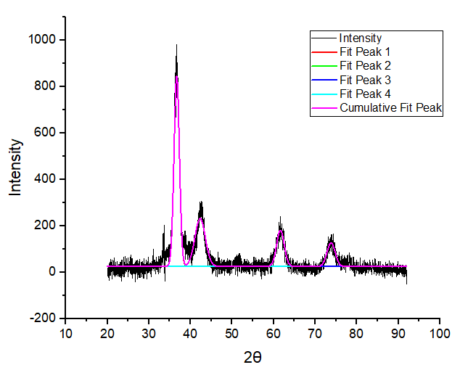

|  |  |  |  |  |  |  |  |
| --- | --- | --- | --- | --- | --- | --- | --- |
| **2θ** | **θ(rad)** | **Bo(fwhm)** | **Bo(rad)** | **Bo2** | **Bi(deg)** | **Bi(rad)** | **Bi2** |
| 36.67767 | 0.320073 | 1.52066 | 0.026541 | 0.000704 | 0.045 | 0.000785 | 6.17E-07 |
| 42.30679 | 0.369196 | 2.95861 | 0.051637 | 0.002666 | 0.045 | 0.000785 | 6.17E-07 |
| 61.62263 | 0.537759 | 2.14505 | 0.037438 | 0.001402 | 0.045 | 0.000785 | 6.17E-07 |
| 73.8236 | 0.644232 | 2.28072 | 0.039806 | 0.001585 | 0.045 | 0.000785 | 6.17E-07 |

|  |  |  |  |
| --- | --- | --- | --- |
| **Br2=Bo2-Bi2** | **Br** | **Brcosθ** | **sinθ** |
| 0.000704 | 0.026529 | 0.025182 | 0.314636 |
| 0.002666 | 0.051632 | 0.048152 | 0.360866 |
| 0.001401 | 0.03743 | 0.032147 | 0.512212 |
| 0.001584 | 0.039798 | 0.031821 | 0.600585 |

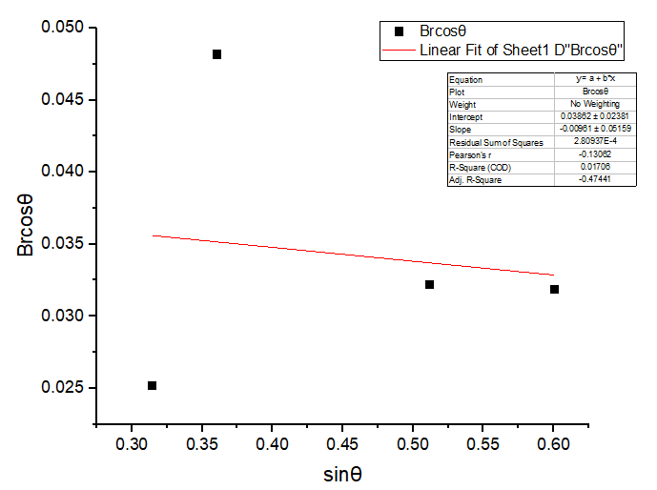

|  |  |
| --- | --- |
| Equation | y = a + b*x |
| Plot | Brcosθ |
| Weight | No Weighting |
| Intercept | 0.03862 ± 0.02381 |
| Slope | -0.00961 ± 0.05159 |
| Residual Sum of Squares | 2.80937E-4 |
| Pearson's r | -0.13062 |
| R-Square (COD) | 0.01706 |
| Adj. R-Square | -0.47441 |

$$b=Slope=η \\ a=Intercept=\frac{kλ}{L} \\ Therefore, η=0.00961 \\ \frac{kλ}{L}=0.03862 \\ L=\frac{kλ}{0.03862} \\ L=\frac{0.94×0.154}{0.03862} \\ L=3.7483\text{ nm}$$

**Result**

$$η=S\text{train in the material=}0.00961 \\ \text{L= Crystallite Size}=3.7483 \text{nm}$$